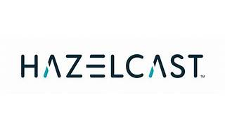

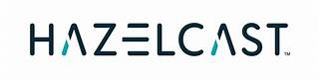

Explore

Certainly! **Hazelcast** is a unified real-time data platform based on Java that combines a fast data store with stream processing. [It’s widely used for in-memory computing and is recognized as the fastest and most scalable approach to application performance1](https://en.wikipedia.org/wiki/Hazelcast). Now, here are **five free reference links** where you can learn more about Hazelcast:

1. [**Hazelcast Overview**](https://docs.hazelcast.com/imdg/3.12/hazelcast-overview): This official documentation provides an in-depth understanding of Hazelcast’s features and usage.
2. [**Hazelcast Platform Explainer Video**](https://www.youtube.com/watch?v=UpIgHzKbMp0): In this video, you’ll get an introduction to the concepts of data in motion and data at rest, and how Hazelcast fits into this landscape[2](https://www.youtube.com/watch?v=UpIgHzKbMp0).
3. [**Gartner’s Revenue Technology Framework**](https://www.gartner.com/en/sales/topics/sales-technologies): Explore how Hazelcast can be part of your sales tech stack using Gartner’s insights.
4. [**NTU Master of Science by Coursework**](https://www.ntu.edu.sg/mse/admissions/postgraduates/prospective-students/master-of-science/coursework): While not directly about Hazelcast, this coursework program covers relevant topics in computer science and technology.
5. [**Keysight**](https://www.keysight.com/sg/en/home.html): Although not exclusively focused on Hazelcast, Keysight offers software-centric design, emulation, and test solutions that align with modern technology trends[3](https://www.keysight.com/sg/en/home.html).

Feel free to explore these resources to deepen your understanding of Hazelcast! 🚀